Cloudfront

* Create an s3 bucket with block public access
* Upload a static website to the s3 (https://www.free-css.com/free-css-templates)  
  A screenshot of a computer

  AI-generated content may be incorrect.
* We won’t be able to access the website from the public  
  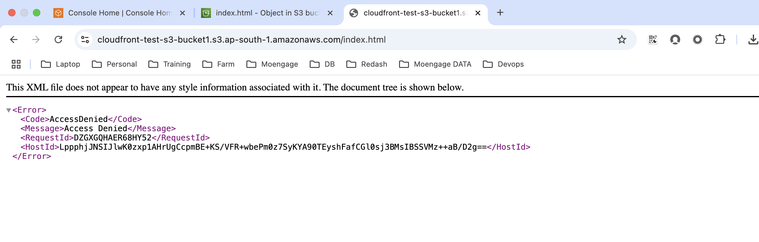
* Create cloudfront distribution  
  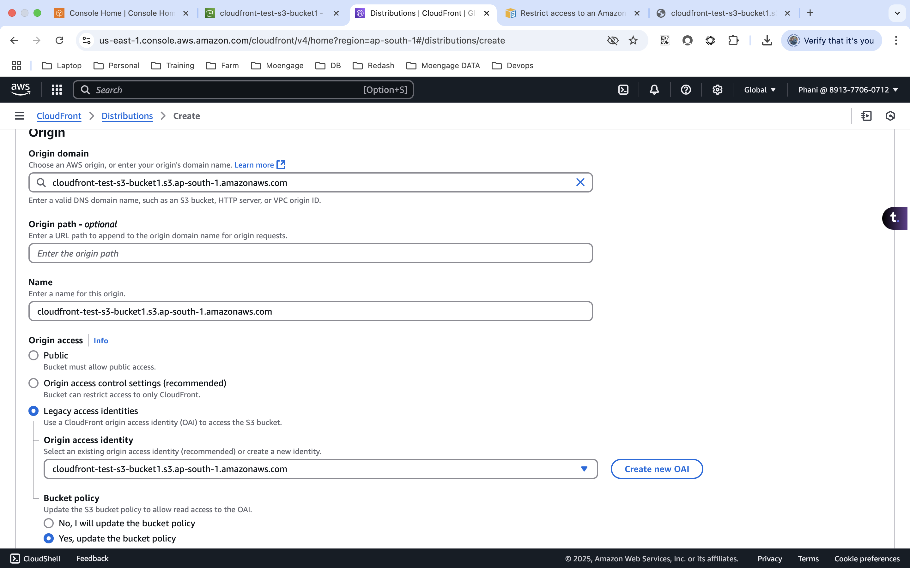  
    
  <https://docs.aws.amazon.com/AmazonCloudFront/latest/DeveloperGuide/private-content-restricting-access-to-s3.html>

* Once the cloud front is created, it will add the permission to the s3 bucket automatically  
    
  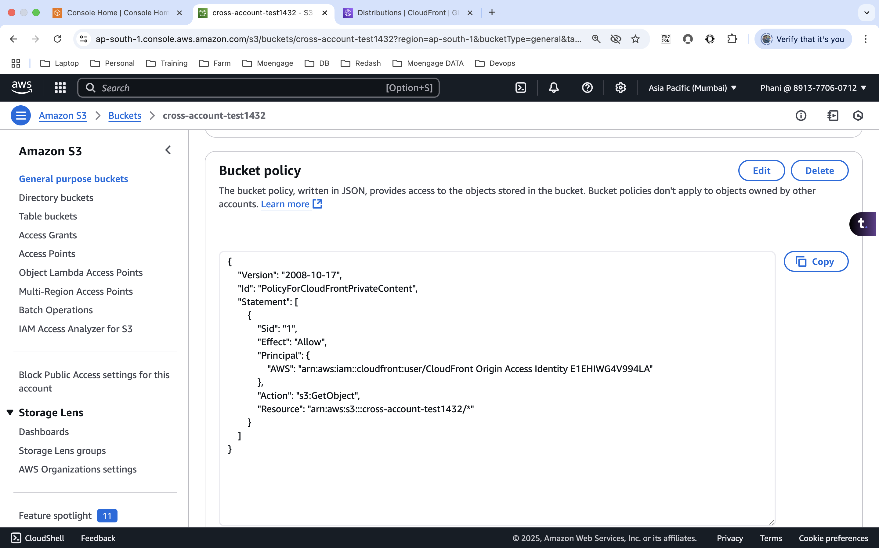
* Distribution domain name

* Accessing the site from the cloud front distribution name  
    
  